Table 4. SU, KW and ER values for multiple experiments
 | S.no | pressure (MPa) | stand of distance (mm) | traverse speed (mm/min) | Mass flow rate (kg/min) | Surface Undulation  (µm) | Erosion Rate(mm³/min) | Kerf Width(mm)
 | 1 | 220 | 2 | 80 | 0.4 | 4.75 | 119.98 | 2.08
 | 2 | 260 | 1 | 64 | 0.55 | 3.09 | 126.36 | 1.44
 | 3 | 220 | 2 | 80 | 0.45 | 4.46 | 122.4 | 1.98
 | 4 | 140 | 3 | 96 | 0.55 | 5.02 | 111.57 | 2.25
 | 5 | 300 | 1 | 96 | 0.35 | 3.84 | 126.63 | 1.75
 | 6 | 140 | 1 | 64 | 0.35 | 5.04 | 97.63 | 2.25
 | 7 | 220 | 2 | 72 | 0.45 | 4.38 | 121.6 | 1.95
 | 8 | 140 | 3 | 64 | 0.55 | 4.61 | 109.81 | 2.09
 | 9 | 280 | 2 | 80 | 0.45 | 4.14 | 137.08 | 1.83
 | 10 | 300 | 1 | 64 | 0.35 | 3.5 | 117.28 | 1.59
 | 11 | 300 | 3 | 96 | 0.35 | 3.97 | 143.3 | 1.86
 | 12 | 220 | 2 | 88 | 0.45 | 4.63 | 125.7 | 2.04
 | 13 | 140 | 3 | 96 | 0.35 | 5.56 | 106.95 | 2.57
 | 14 | 300 | 3 | 96 | 0.55 | 3.62 | 148.41 | 1.64
 | 15 | 140 | 1 | 64 | 0.55 | 4.08 | 102.02 | 1.86
 | 16 | 180 | 2 | 80 | 0.45 | 4.75 | 115.2 | 2.15
 | 17 | 220 | 2 | 80 | 0.45 | 4.46 | 122.4 | 1.98
 | 18 | 220 | 1.5 | 80 | 0.45 | 4.41 | 119.69 | 1.96
 | 19 | 300 | 3 | 64 | 0.55 | 3.42 | 145.92 | 1.52
 | 20 | 220 | 2 | 80 | 0.5 | 4.27 | 131.74 | 1.93
 | 21 | 220 | 2.5 | 80 | 0.45 | 4.67 | 132.71 | 2.05
 | 22 | 140 | 1 | 96 | 0.35 | 5.36 | 99.7 | 2.43
 | 23 | 300 | 1 | 96 | 0.55 | 3.29 | 140.98 | 1.48
 | 24 | 220 | 2 | 80 | 0.45 | 4.46 | 122.4 | 1.98
 | 25 | 140 | 1 | 96 | 0.55 | 4.53 | 104.26 | 2.08
 | 26 | 140 | 3 | 64 | 0.35 | 5.23 | 103.66 | 2.34
 | 27 | 300 | 3 | 64 | 0.35 | 3.80 | 139.85 | 1.73

Table 5: Hyperparametrs for optimized models.
Output | SVR  Hyper  parameter | SVR  R² | Elasticnet  Hyper  parameter | EN R² | XGB Hyper  parameter | XGB  R² | NN Hyper  parameter | NN  R²
Surface Undulation | {'C': 10, 'kernel': 'rbf', 'gamma': 'scale'} | 0.981 | {'alpha': 0.1, 'l1_ratio': 0.5} | 0.887 | {n_estimators=100, max_depth=5, learning_rate=0.05} | 1.000 | {'hidden_layer_sizes': architecture=(6,4,3), alpha=0.001, learning_rate=0.0} | 0.994
Erosion Rate | {'C': 10, 'kernel': 'rbf', 'gamma': 'scale'} | 0.888 | {'alpha': 0.1, 'l1_ratio': 0.5} | 0.939 | {'n_estimators':100,  'max_depth':5,  'learning_rate':0.05,  'subsample':0.8} | 0.999 | {'hidden_layer_sizes:'  architecture=(8,5,4), alpha=0.001, learning_rate=0.01} | 0.915
Kerf Width | {'C': 10, 'kernel': 'rbf', 'gamma': 'scale'} | 0.913 | {'alpha': 0.1, 'l1_ratio': 0.5} | 0.813 | {'n_estimators':100,  'max_depth':5  ,'learning_rate':0.05,  'subsample':0.8} | 0.999 | {'hidden_layer_sizes': architecture=(6,3,2), alpha=0.001, learning_rate=0.01} | 1.000
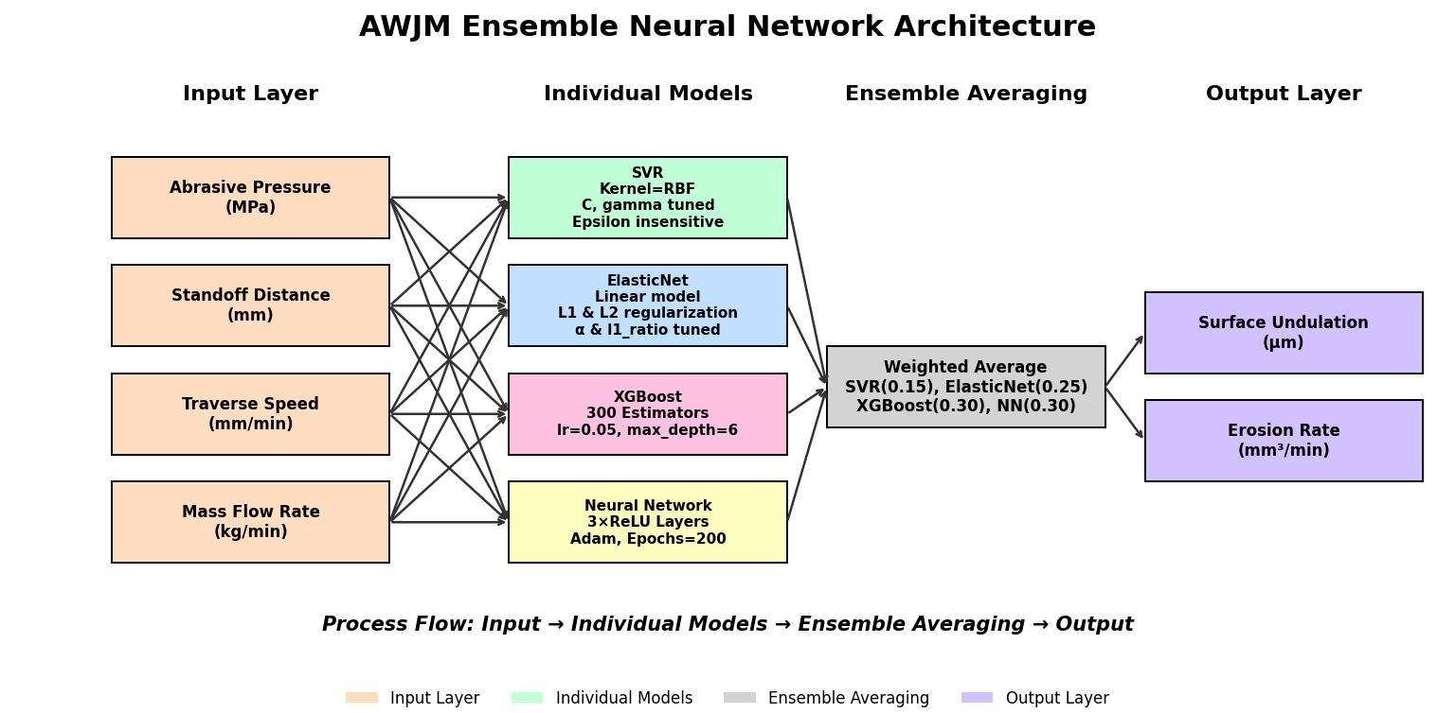

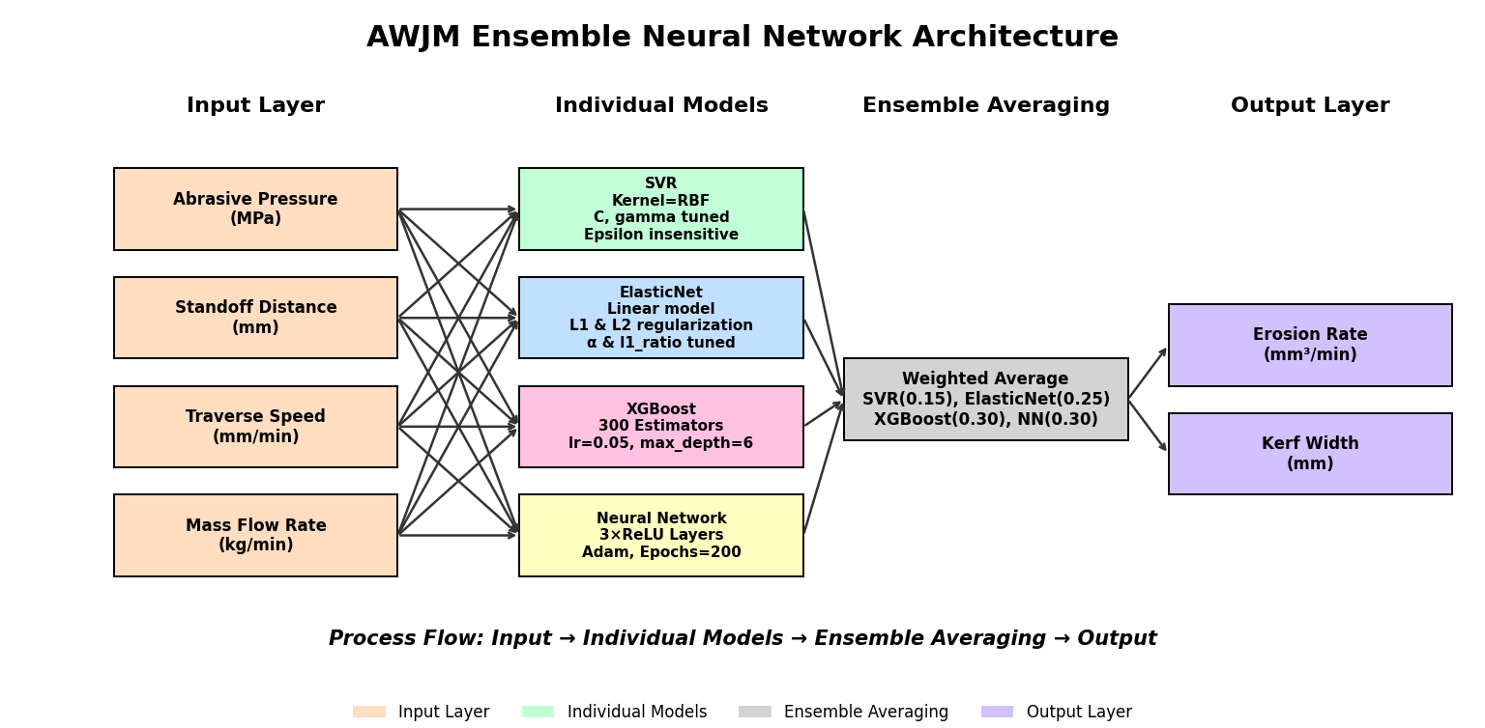

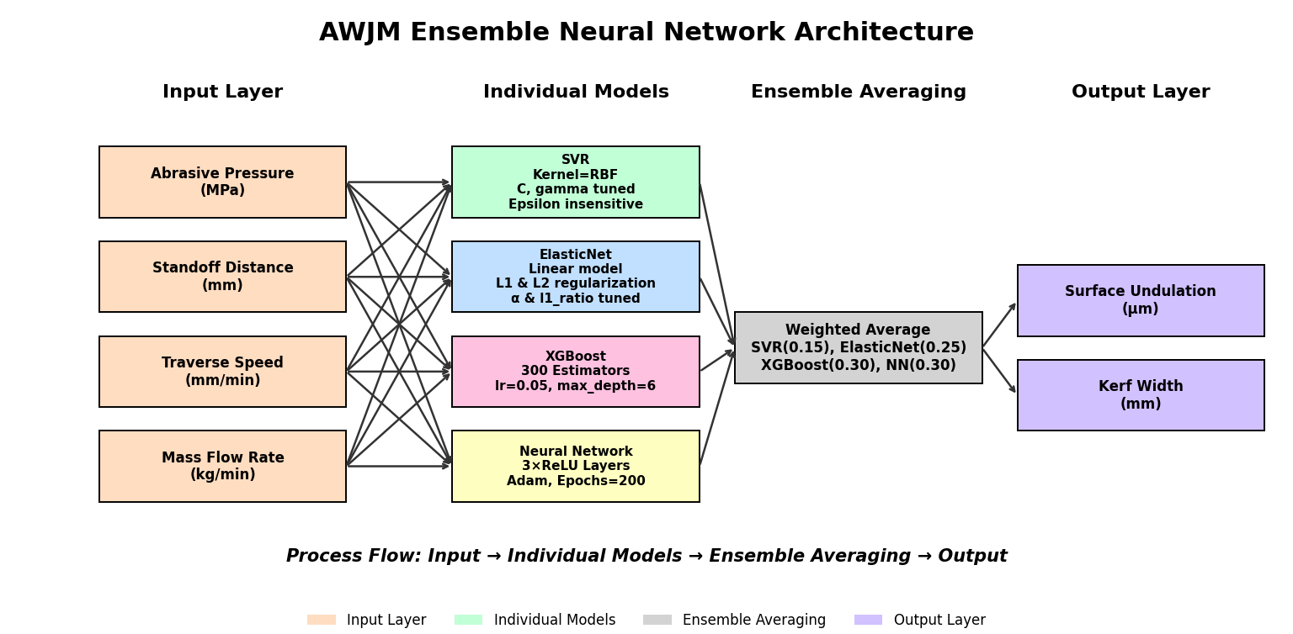

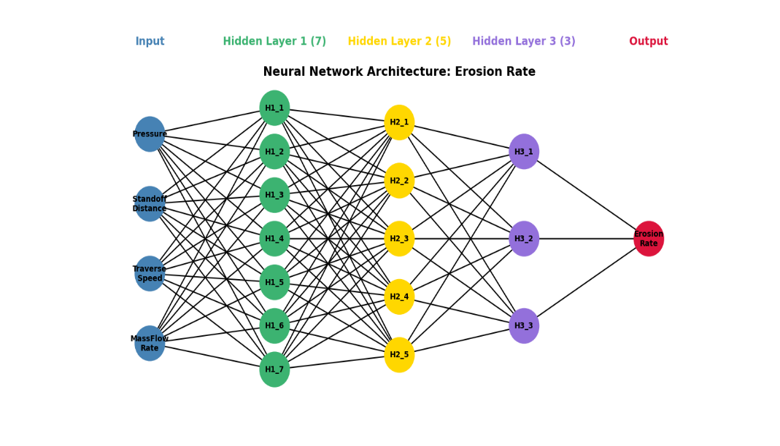
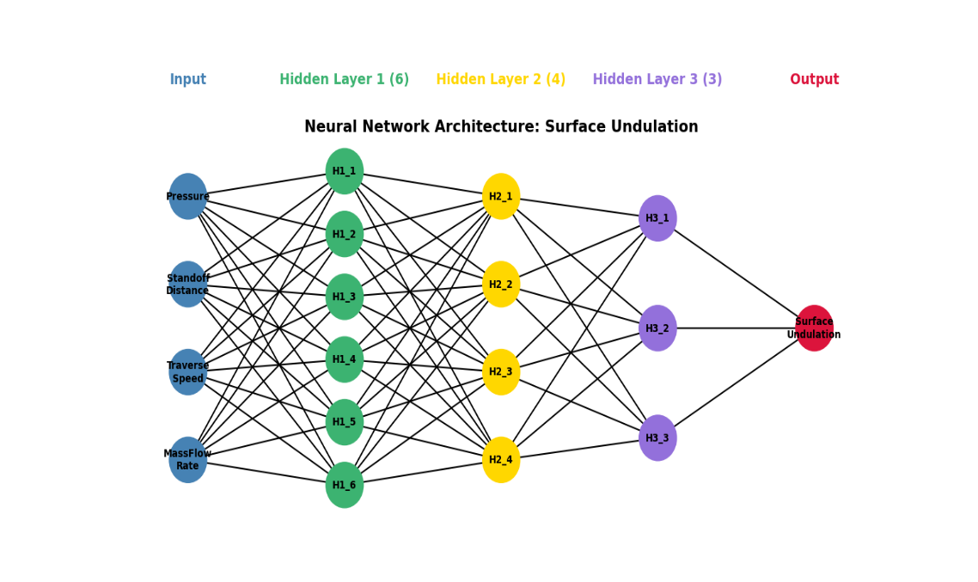

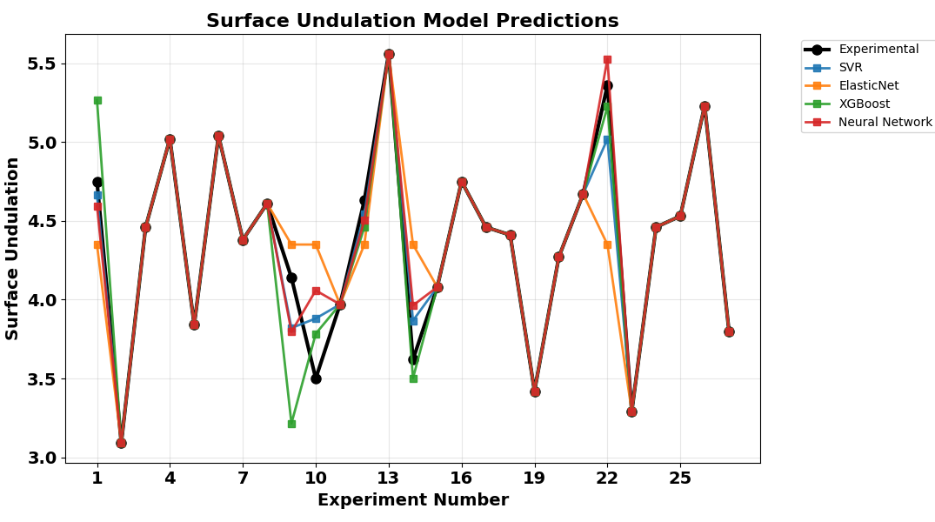
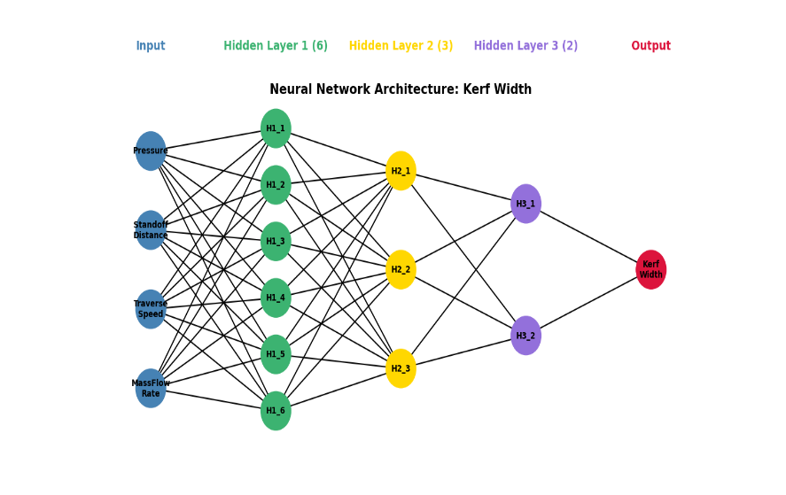

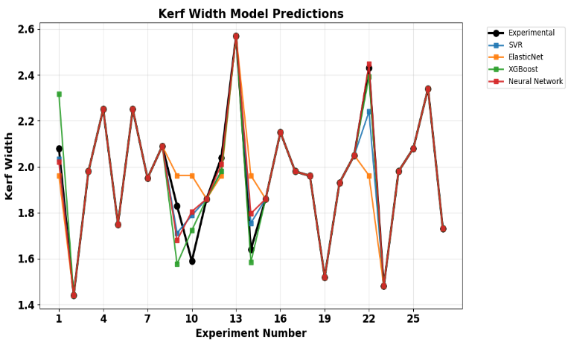
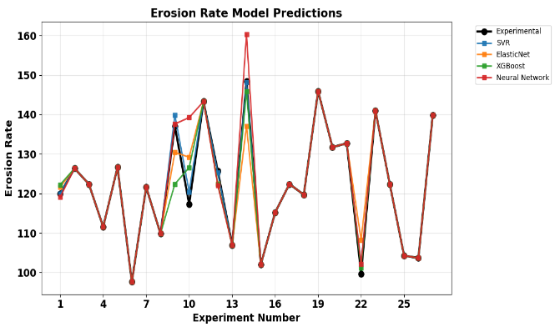

Fig. 7. Validation of each model with experimental value

Table 6: Ensemble Model performance.
Ensemble Model Performance Summary
Target | RMSE | MAE | R²
Surface Undulation | 0.0706 | 0.0593 | 0.9872
Erosion Rate | 1.4826 | 1.1811 | 0.9894
Kerf Width | 0.0437 | 0.0363 | 0.9751

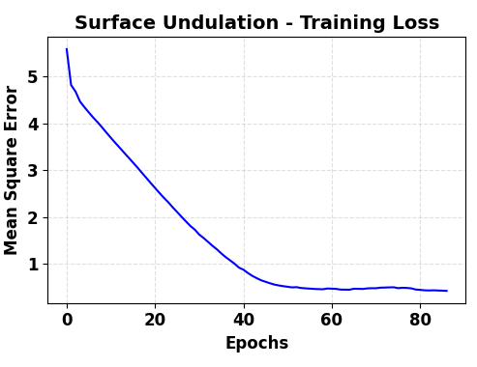
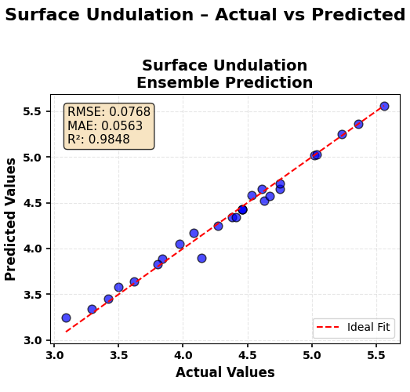
SURFACE UNDULATION:
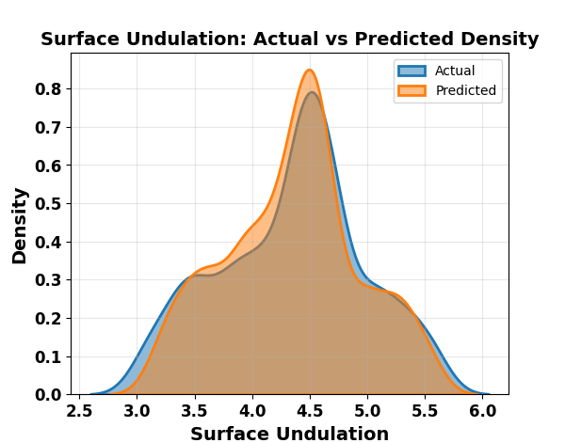

(a) (b) (c)
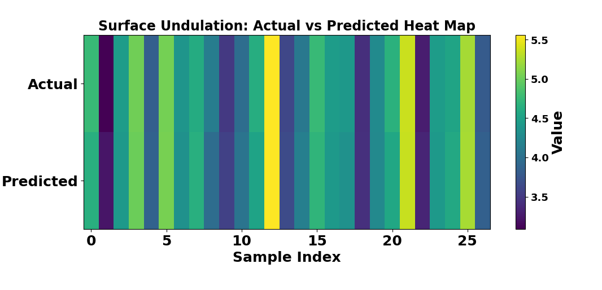

Fig. 8. Ensemble Surface Undulation Model Performance (a) Training and Validation Curve (b) Actual vs Predicted value (c) Density curve (d) Heat map.

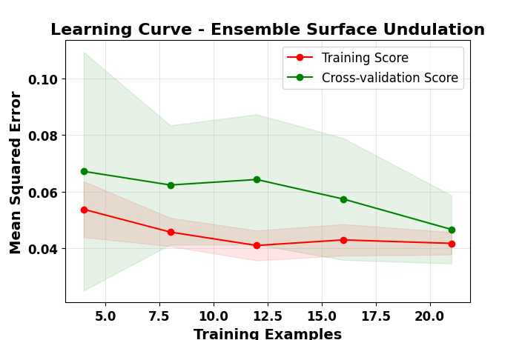
Fig. 11. Learning curve for Cross-validation Surface Undulation.

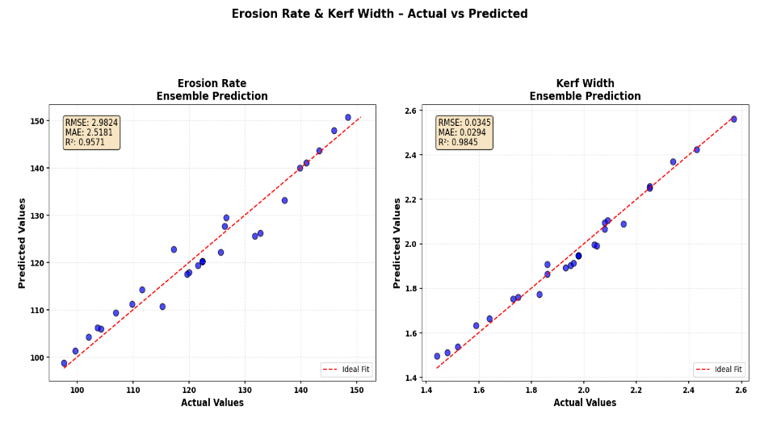
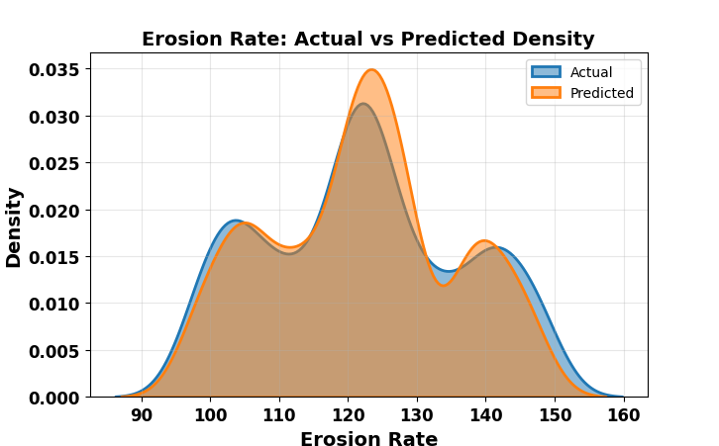
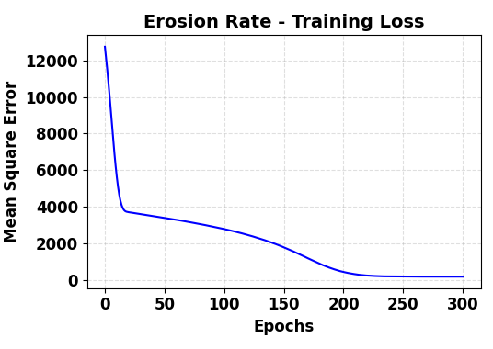
Erosion Rate

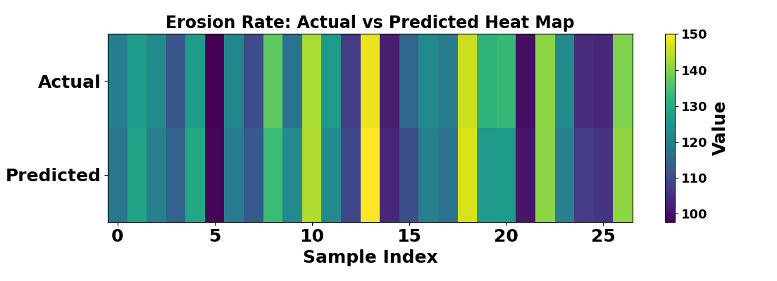

Fig. 8. Ensemble Erosion Rate Model Performance (a) Training and Validation Curve (b) Actual vs Predicted value (c) Density curve (d) Heat map.

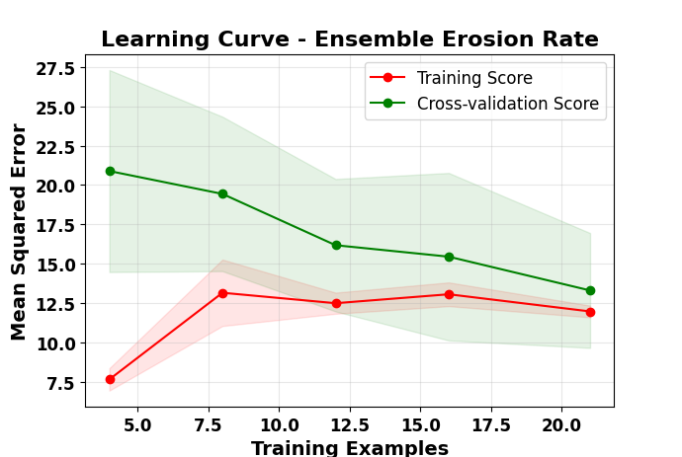

Fig. 11. Learning curve for Cross-validation Erosion Rate

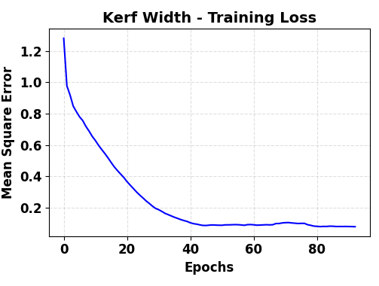
KERF WIDTH
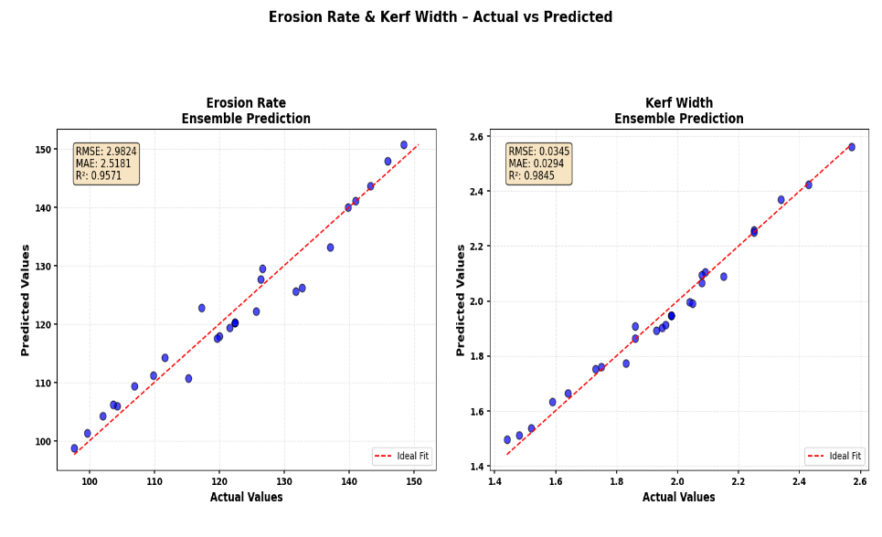
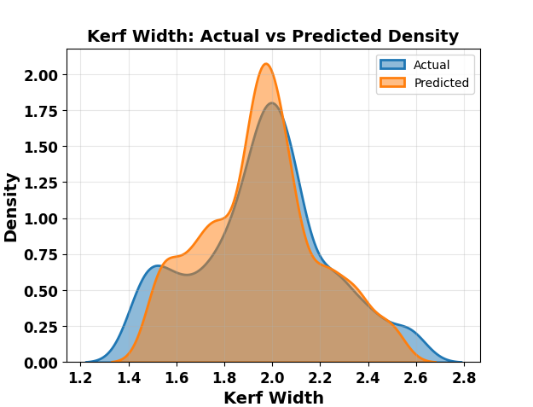

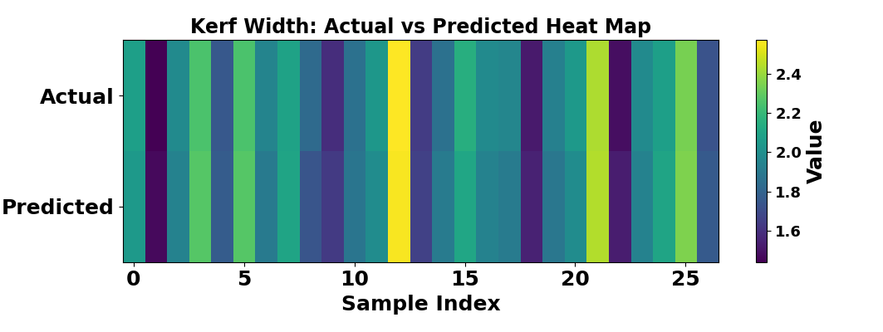

Fig. 8. Ensemble Kerf width Performance (a) Training and Validation Curve (b) Actual vs Predicted value (c) Density curve (d) Heat map.

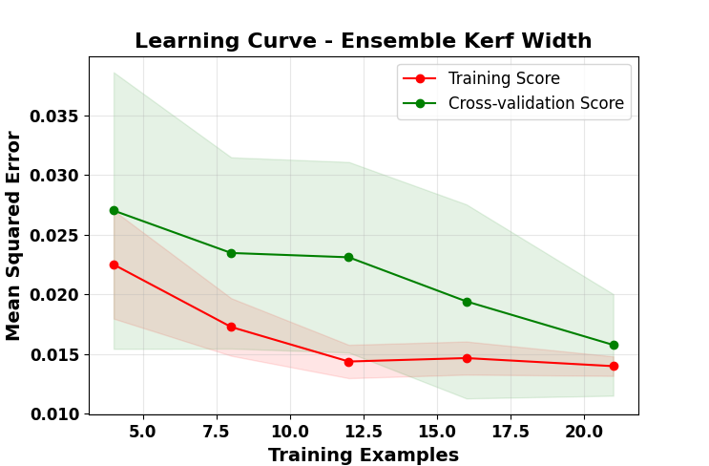

Fig. 11. Learning curve for Cross-validation Kerf Width.

Distribution:
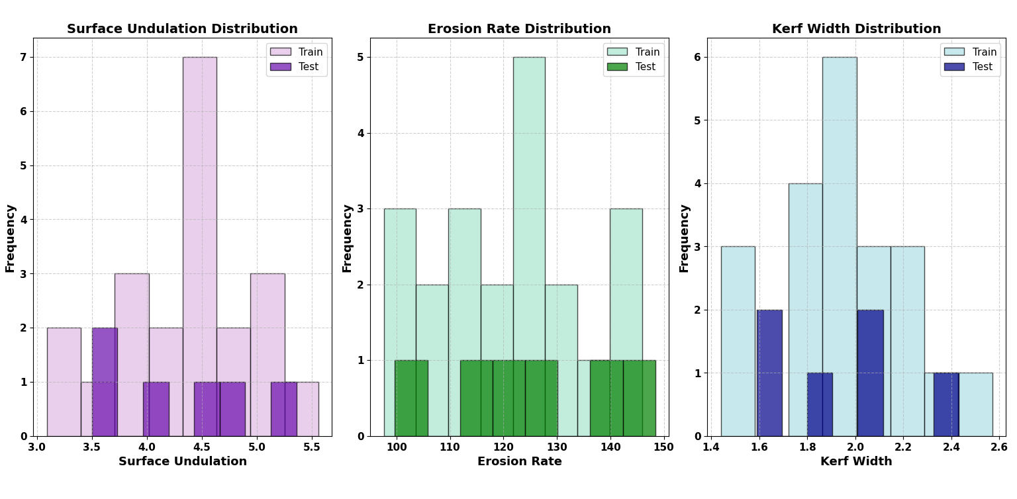

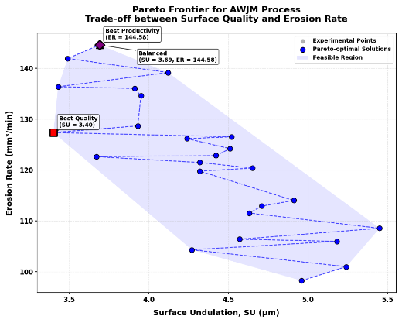
Table 3: Optimal Process Parameter Settings for Different Objectives
Parameter | Min SU | Max ER | Balanced
Pressure (MPa) | 260.00 | 300.00 | 300.00
Standoff Distance (mm) | 1.00 | 3.00 | 3.00
Traverse Speed (mm/min) | 64.00 | 96.00 | 96.00
Mass Flow Rate (kg/min) | 0.55 | 0.55 | 0.55
Expected SU (μm) | 3.22 | 3.67 | 3.67
Expected ER (mm³/min) | 126.48 | 148.81 | 148.81

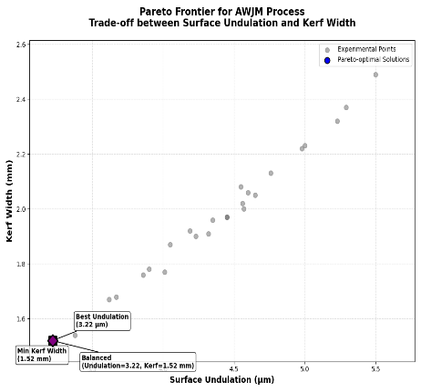
Table 3: Optimal Process Parameter Settings for Different Objectives
Parameter | Min SU | Min Kerf | Balanced
Pressure (MPa) | 260.00 | 260.00 | 260.00
Standoff Distance (mm) | 1.00 | 1.00 | 1.00
Traverse Speed (mm/min) | 64.00 | 64.00 | 64.00
Mass Flow Rate (kg/min) | 0.55 | 0.55 | 0.55
Expected SU (μm) | 3.22 | 3.22 | 3.22
Expected Kerf(mm) | 1.52 | 1.52 | 1.52

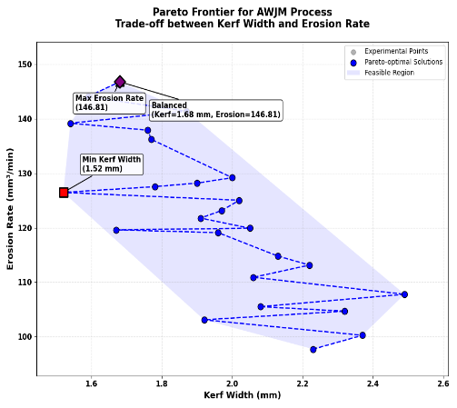
Table 3: Optimal Process Parameter Settings for Different Objectives
Parameter | Min Kerf | Max ER | Balanced
Pressure (MPa) | 260.00 | 300.00 | 300.00
Standoff Distance (mm) | 1.00 | 3.00 | 3.00
Traverse Speed (mm/min) | 64.00 | 96.00 | 96.00
Mass Flow Rate (kg/min) | 0.55 | 0.55 | 0.55
Expected Kerf (mm) | 1.52 | 1.68 | 1.68
Expected ER (mm³/min) | 126.48 | 146.81 | 146.81

Table 3: Optimal Process Parameter Settings for Different Objectives

BOOSTRAP
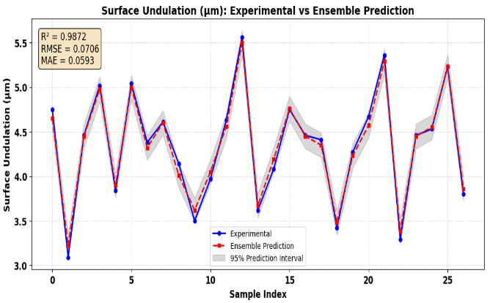
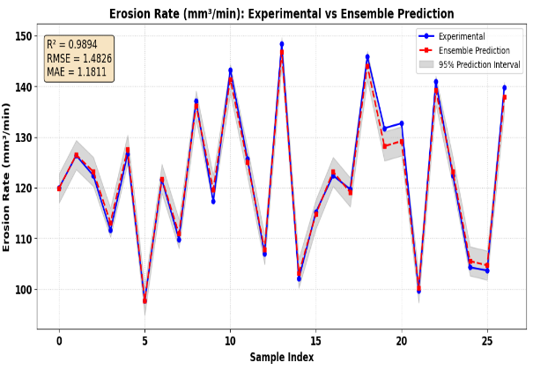

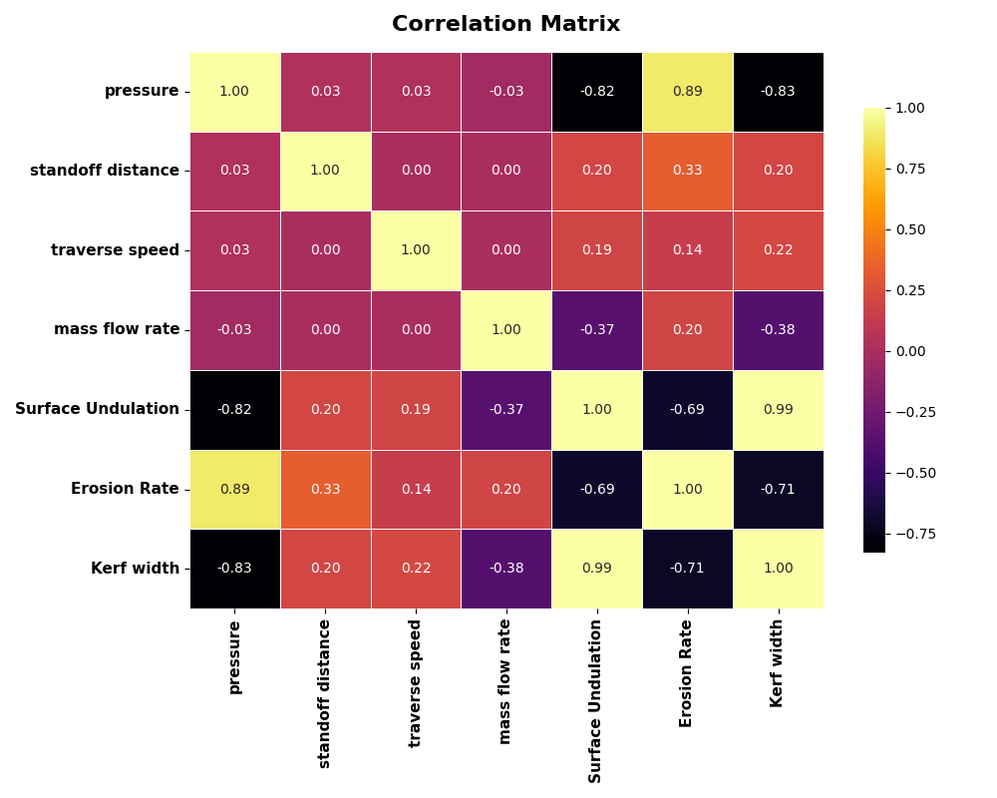
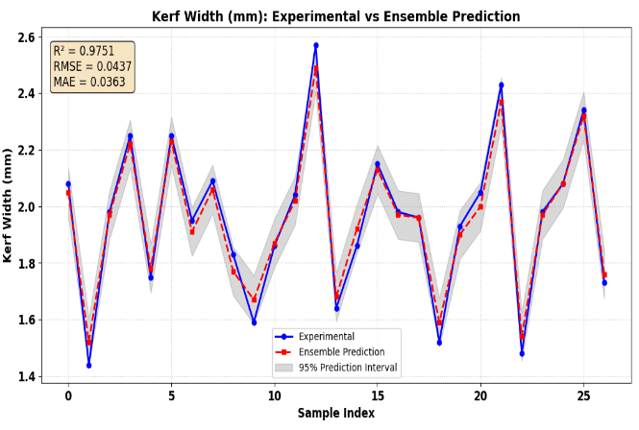

HYBRID Ensemble

